

CMPE360

Project 3

Blender Basics

Section 02

Erkan Sancak

44293566706

**PART 1**

Part1.a) Rendered Image with 1920x1080.

Checkpoint 1: Save the Rendered Image of the Default Sphere

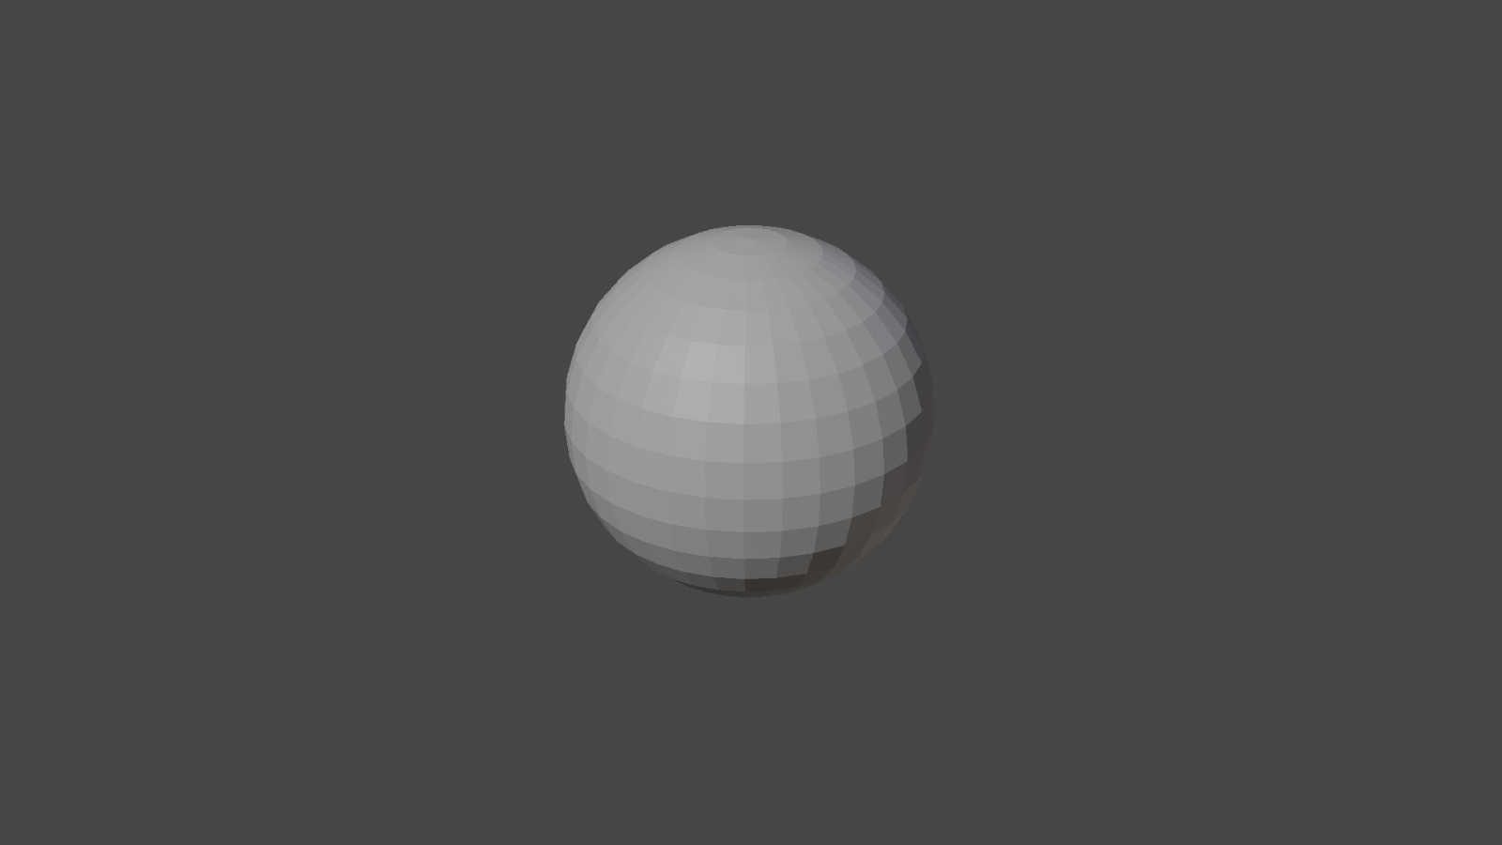

Checkpoint 2: Save the Rendered Image of the new scene that have a plane and sphere with changes.

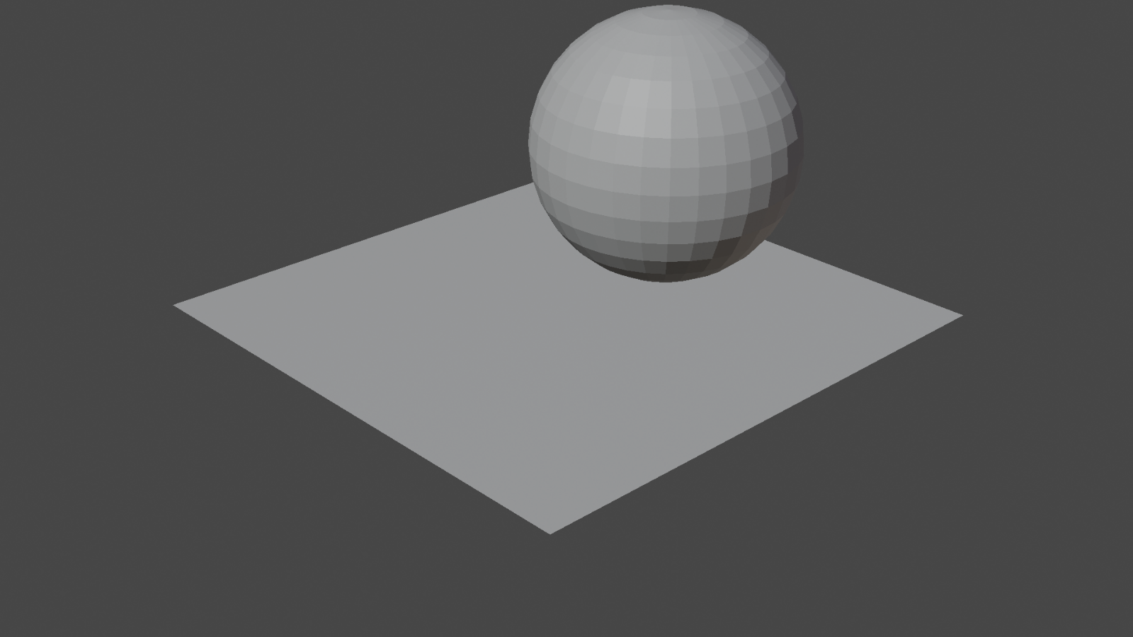

Checkpoint 2.1: Save the Rendered Image of the new scene that have a plane, sphere and cube with changes.

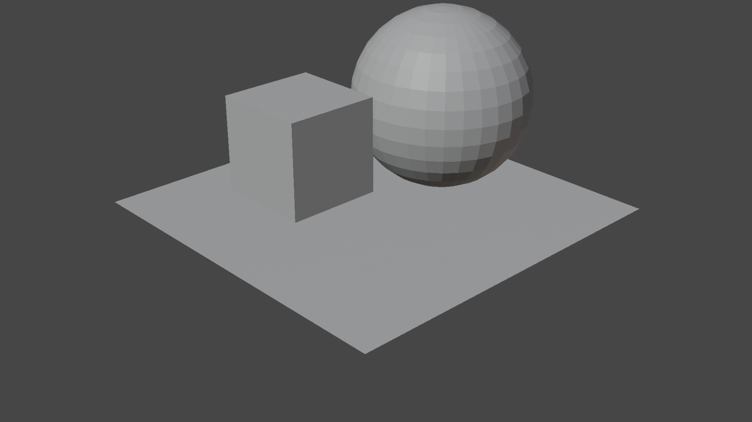

Checkpoint 3 : Save the Rendered Image of a purple Sphere, green Cube and blue Plane.

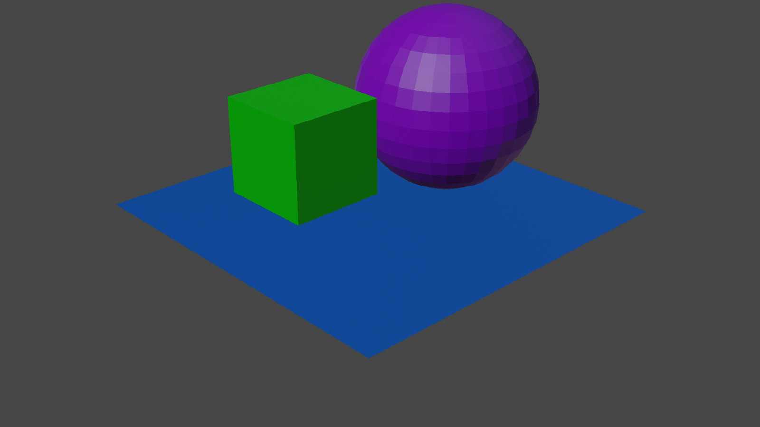

Part1.b) Rendered Image with 160x90.

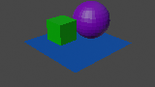

Part1.c) Rendered Image with 3840x2160

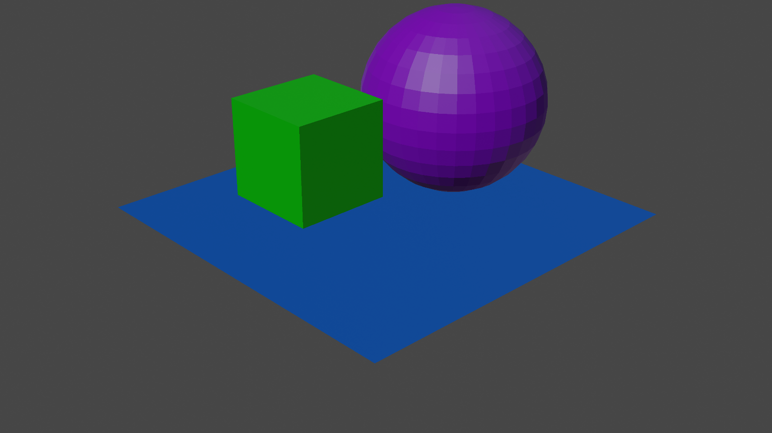

Part1.d) Compare the images that are 1920x1080, 160x90 and 3840x2160. Write the

effect of changing the resolution.

Changing the resolution of an image can have a significant impact on its quality. The most noticeable change is the size of the image in terms of its dimensions and clarity detail of the images. The file size of the image increases with higher resolutions because it contains more pixel.

Part1.e) Rendered Image with gamma 1.



Part1.f) Rendered Image with gamma 3.

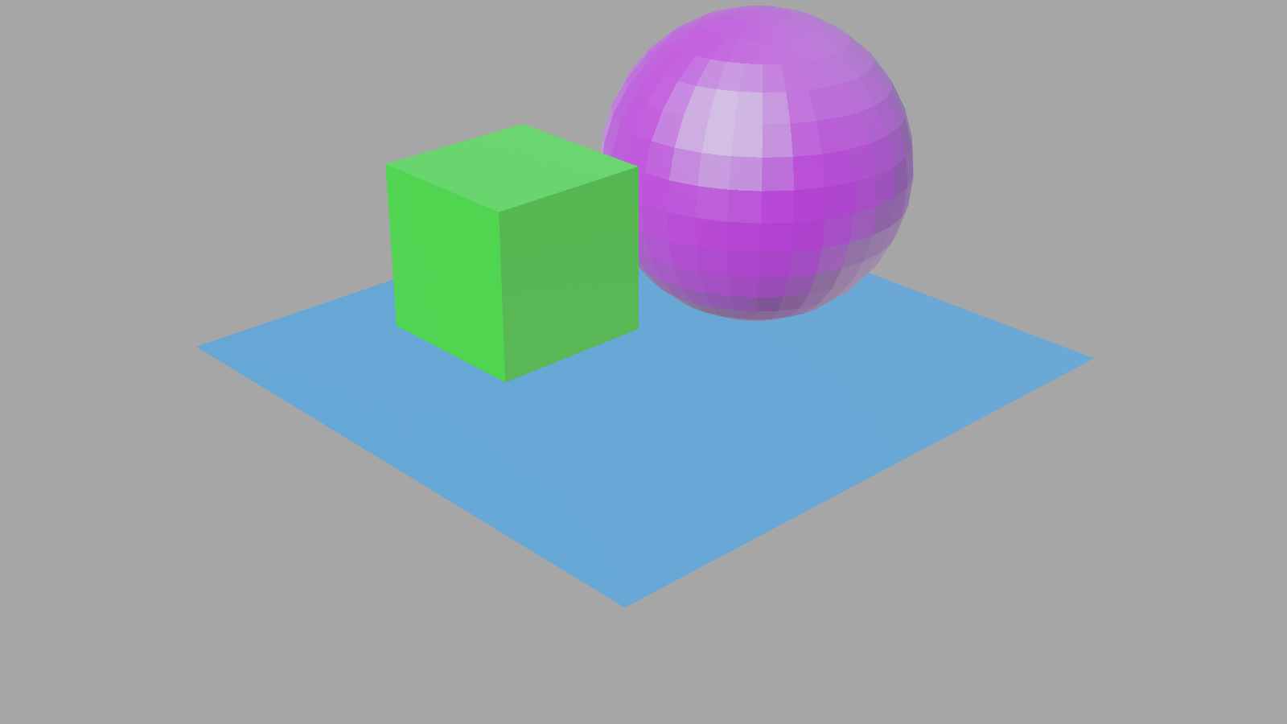

Part1.g) Rendered Image with gamma 5

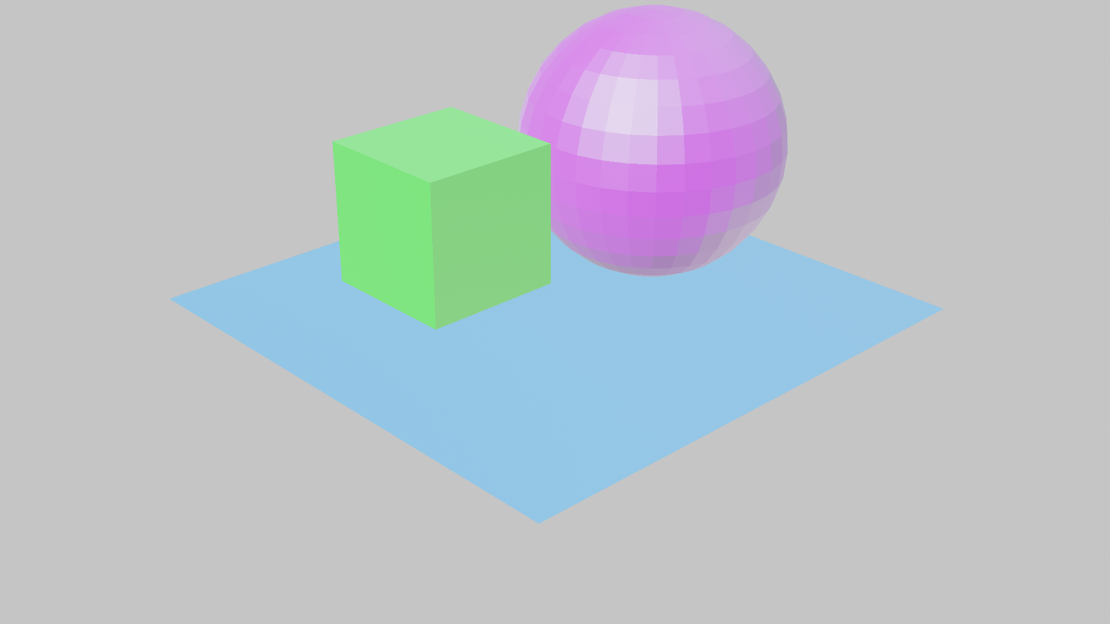

Part1.h) Compare the images that have gamma value 1,3 and 5. Write the effect of

changing the gamma value.

The specific impact depends on whether gamma is increased or decreased and the degree of adjustment applied. Higher gamma values are makes image colors brighter, lower values makes image colors darker.

Part1.i) What's the advantage of using YUV color space?

YUV color space is advantageous for video applications because it efficiently separates brightness (luminance) and color (chrominance) information. This separation is beneficial for video compression, transmission, broadcasting, and post-production tasks, improving video quality, reducing bandwidth needs, and simplifying color adjustments.

**PART 2**

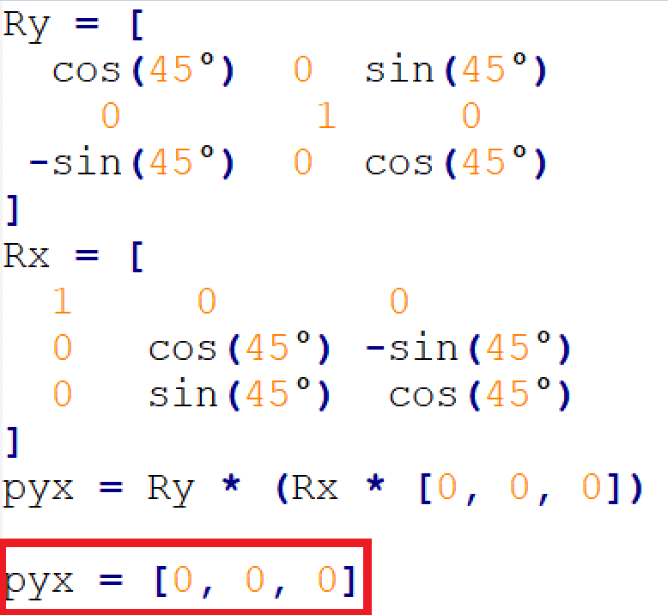Part2.a/c) Write down $p_{xy}$ Part2.b/c) Write down $p_{yx}$

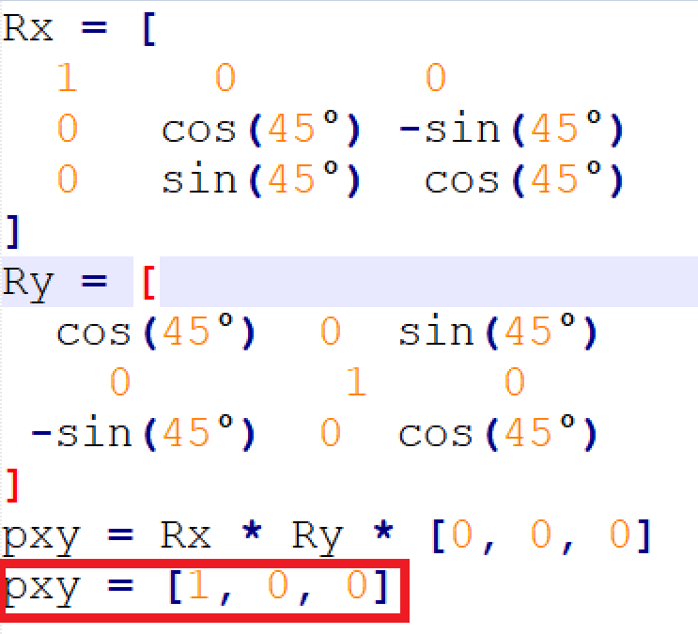

Part2.d/f) Write down $t_{1}{cube}^{world}$

Global location of the cube (t1_cube_world) is **(4, -1, 2)** when the plane has a world location of (3, 2, 1) and the cube has a local position relative to the plane of (1, -3, 1).

So $t_{1}{cube}^{world}=\left(\begin{matrix}4 \\ -1 \\ 2\end{matrix}\right)$

Part2.e/f) Write down $t_{2}{cube}^{world}$

$$t_{2}{cube}^{world}≈\left(\begin{matrix}4 \\ 0.58 \\ 3.8\end{matrix}\right)$$

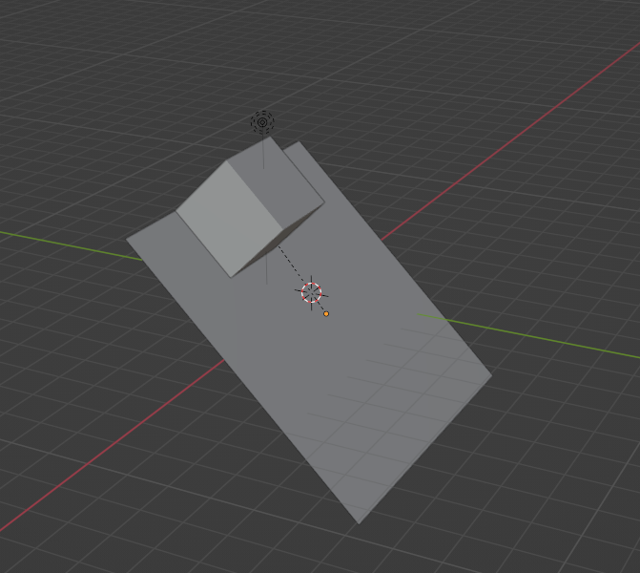

Part2. g) Save the rendered images under these three camera settings

Set the camera location to (0,-6,0) and rotation to (90,0,0) and change its focal length to 25mm

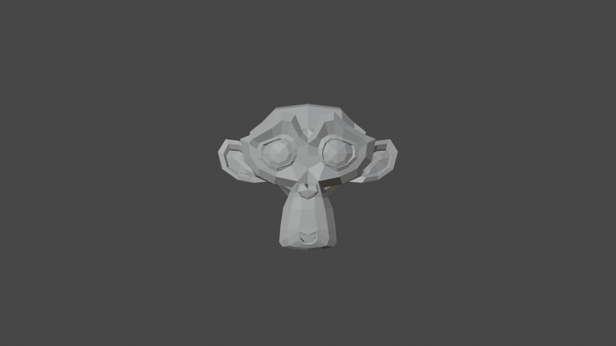

Change the camera location to (0,-10, 0) and focal length to 60 mm.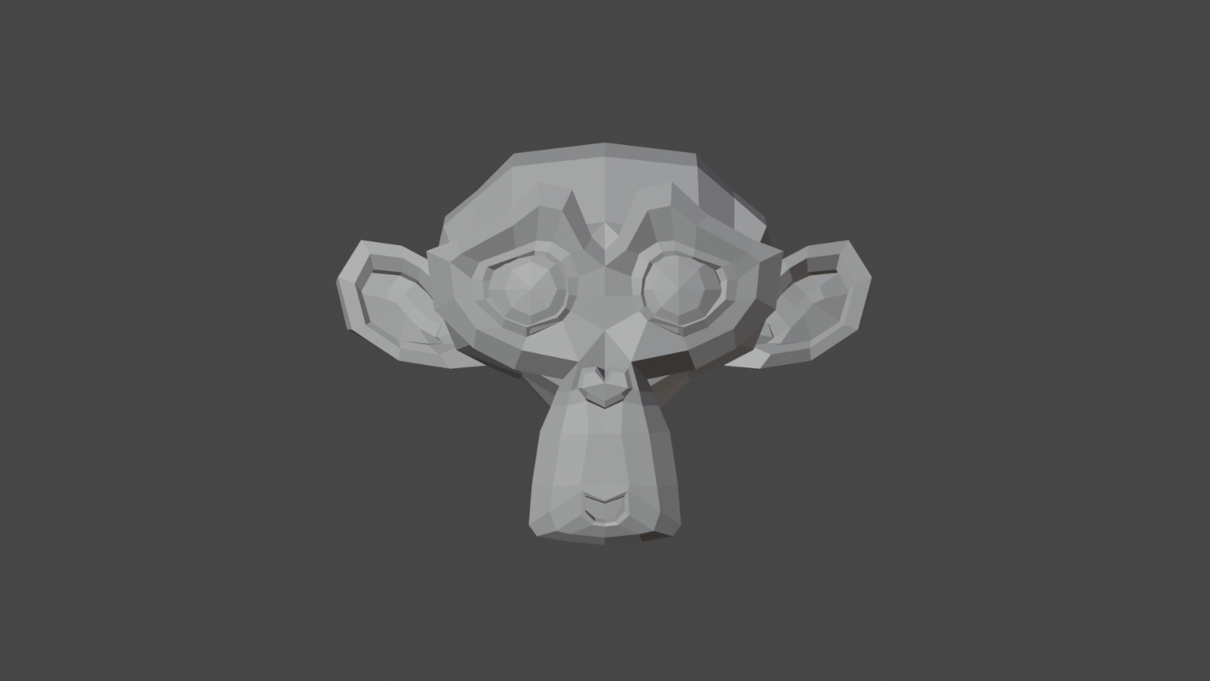

Change the camera location to (0,-20, 0) and focal length to 120 mm.

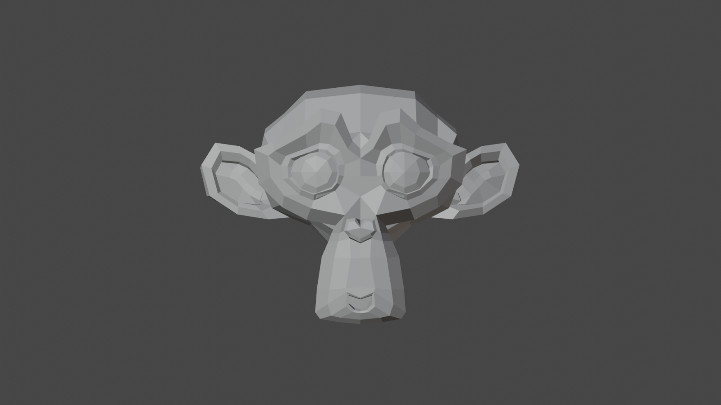

Part2.h) Compare the three images in Checkpoint 3. Discuss the effect of changing the focal length.

Changing the focal length of a camera affects the field of view and perspective in the rendered image. A shorter focal length captures a broader scene making objects appear smaller in the frame. A longer focal length narrows the field of view, flattens perspective, and magnifies objects, making them appear closer together in the frame.

Part2. i) Save the image with flat lighting. Write the effect of flat lighting.



Flat lighting in Blender eliminates shading effects, rendering objects uniformly without shadows or highlights. This creates a consistent and evenly lit appearance in the image.

Part2.j) Save the rendered the image with lower light power

Checkpoint 8: Render the image.

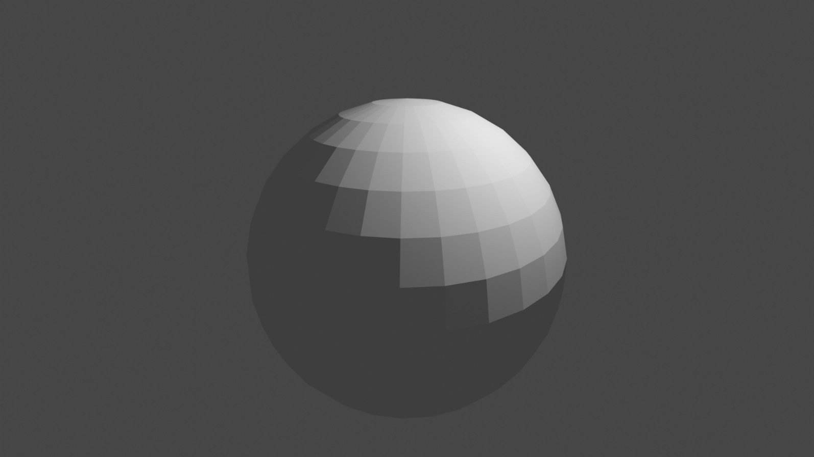

Checkpoint 8.1: Render the image with lower light power.

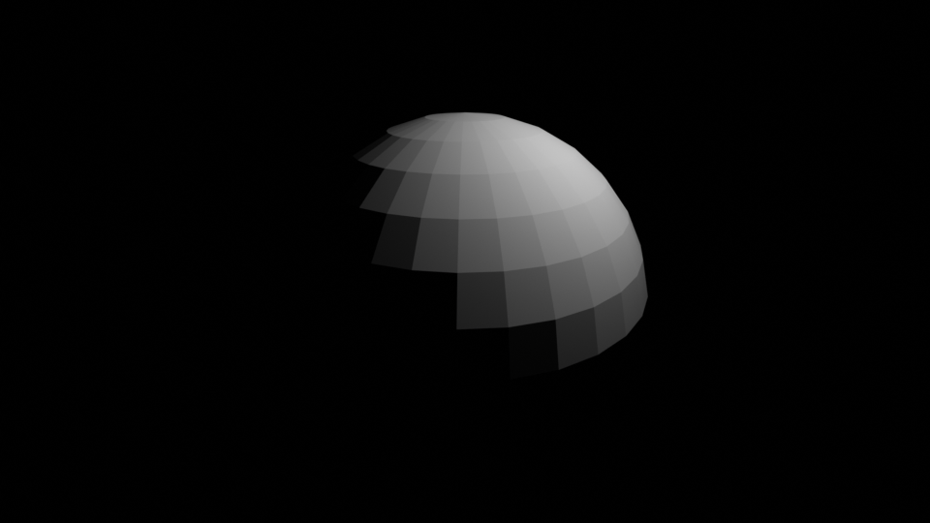

Part2.k) Compare the rendered checkpoint 8 with 8.1 State the relationship between light

power and irradiance. 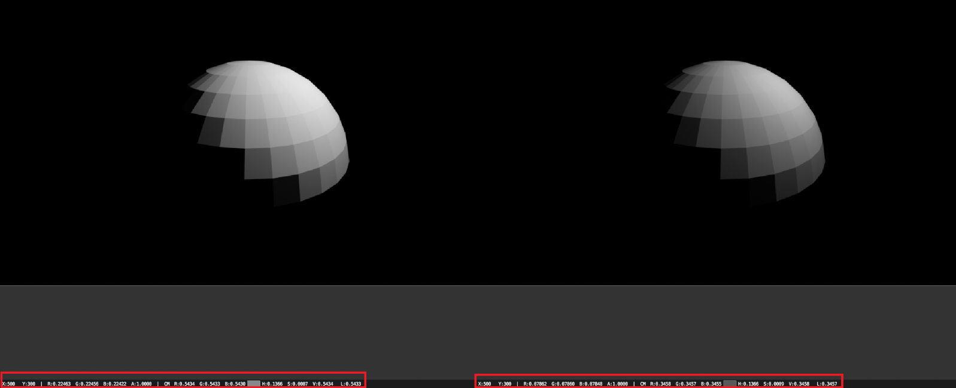

When a pixel with the same coordinates is selected on normally illuminated and less illuminated images, it can be observed that the RGB values ​​in the less illuminated image are much lower.

Part2.l) Save the rendered the images with the area light.

Checkpoint 8.3: Render the image with the area light(disk).

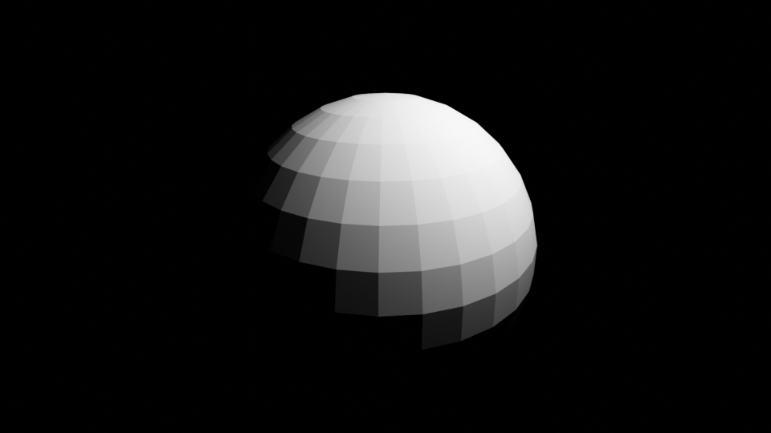

Checkpoint 8.4: Render the image with the area light(square). 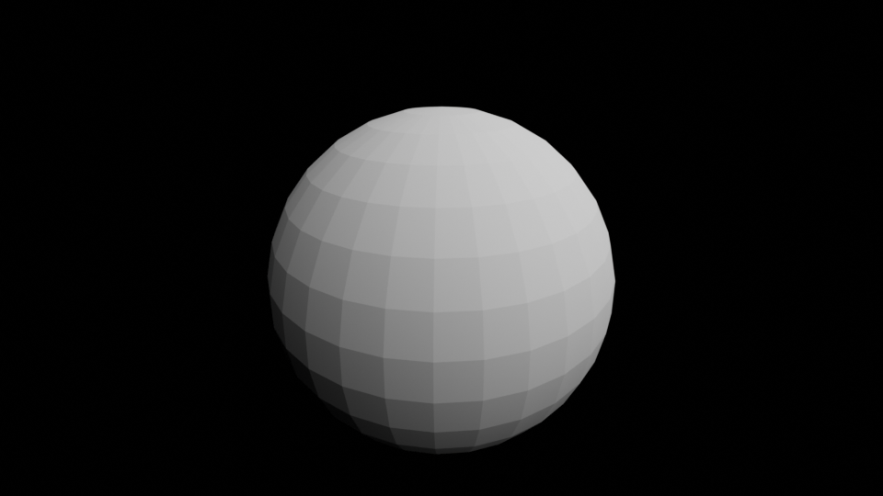

Part2.m) Save the rendered the image with the spot light.

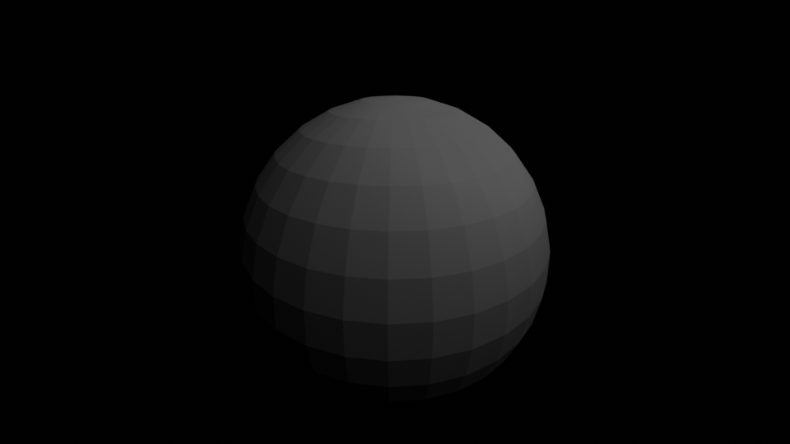

Part2.n) Compare Checkpoint 8, Checkpoint 8.3, Checkpoint 8.4 and Checkpoint 8.5. Discuss

how the shadow looks different between the point light, spot light and area light.

Point light creates sharp, well-defined shadows, spot light has focused shadows with a defined direction, and area light produces soft and diffused shadows with less distinct edges.